HOLIDAY HOMEWORK

Multiple Choice Question
- The point which lies on x-axis at a distance of 3 units in the positive direction of x-axis is
a) (0, −3)
b) (0, 3)
c) (3, 0)
d) (−3, 0)
- The length of the sides of a triangle are 5 cm, 7 cm and 8 cm. Area of the triangle is:
a) 100√3 cm²
b) 10√3 cm²
c) 300 cm²
d) 50√3 cm²
- In the figure, O is the centre of the circle. If ∠ABC = 20°, then ∠AOC is equal to:
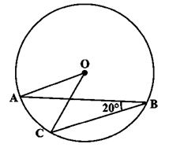
a) 60°
b) 10°
c) 40°
d) 20°
- The value of x⁰ + x¹ − x² + x³ is equal to
a) x⁴
b) 0
c) x
d) 1
- In a trapezium ABCD, E and F are the midpoints of the diagonals AC and BD respectively. Then EF = ?
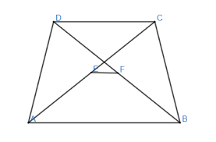
a) ½ AB
b) ½ (AB + CD)
c) ½ (AB − CD)
d) ½ CD
- D, E and F are the midpoints of sides AB, BC and CA of ΔABC. If perimeter of ΔABC is 16 cm, then perimeter of ΔDEF is
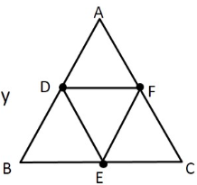
a) 32 cm
b) 8 cm
c) 28 cm
d) 4 cm
- x = 2, y = −1 is a solution of the linear equation
a) 2x + y = 0
b) x + 2y = 0
c) x + 2y = 4
d) 2x + y = 5
- If x − 3 is a factor of x² − ax − 15, then a =
a) 5
b) −2
c) −5
d) 3
- The value of 15√15 ÷ 3√5 is
a) 5√3
b) 3√5
c) 3
d) 5
- ABCD is a parallelogram. If is produced to E such that ED bisects BC at O. Then which of the following is correct?
a) OC = BE
b) OE = OC
c) AB = OE
d) AB = BE
- An irrational number between 1/7 and 2/7 is
a) √(1/7 × 2/7)
b) ½ (1/7 − 2/7)
c) (1/7 × 2/7)
d) ½ (1/7 + 2/7)
- How many linear equations in ‘x’ and ‘y’ can be satisfied by x = 1, y = 2?
a) Infinitely many
b) Two
c) Only one
d) Three

- In a figure, if OP ∥ RS, ∠OPQ = 110° and ∠QRS = 130°, then ∠PQR is equal to
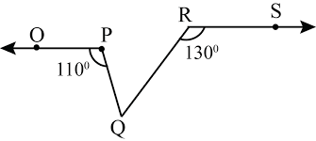
a) 40°
b) 50°
c) 70°
d) 60°
- After rationalising the denominator of 7 / (3√3 − 2√2), we get the denominator as
a) 5
b) 35
c) 19
d) 13
- In the given figure, O is the centre of a circle and chords AC and BD intersect at E. If ∠AEB = 110° and ∠CBE = 30°, then ∠ADB = ?
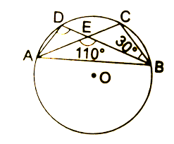
a) 80°
b) 60°
c) 90°
d) 70°
- x-coordinate is known as
a) Origin b) Points
c) Abscissa d) Ordinate
- If (−2, 5) is a solution of 2x + my = 11, then the value of ‘m’ is
a) −2
b) 2
c) 3
d) −3
- The value of $\frac{( a² - b² )³ + ( b² - c² )³ + ( c² - a² )³}{( a - b )³ + ( b - c )³ + ( c - a )³}$ is
a) 3(a − b)(b − c)(c − a)
b) (a + b)(b + c)(c + a)
c) 3(a + b)(b + c)(c + a)
d) 2(a − b)(b − c)(c − a)
- Assertion (A): If the diagonals of a parallelogram ABCD are equal, then ∠ABC = 90°.
Reason (R): If the diagonals of a parallelogram are equal, it becomes a rectangle.
a) Both A and R are true and R is the correct explanation of A.
b) Both A and R are true but R is not the correct explanation of A.
c) A is true but R is false.
d) A is false but R is true.
- Assertion (A): 2 + √6 is an irrational number.
Reason (R): Sum of a rational number and an irrational number is always an irrational number.
a) Both A and R are true and R is the correct explanation of A.
b) Both A and R are true but R is not the correct explanation of A.
c) A is true but R is false.
d) A is false but R is true.

Case- Study
- Read the following text carefully and answer the questions that follow:
Peter, Kevin James, Reeta and Veena were students of Class 9th B at Govt Sr Sec School, Sector 5, Gurgaon.
Once the teacher told Peter to think a number x and to Kevin to think another number y so that the difference of the numbers is 10 (x > y).
Now the teacher asked James to add double of Peter’s number and that three times of Kevin’s number, the total was found 120.
Reeta just entered in the class, she did not know any number.
The teacher said Reeta to form the 1st equation with two variables x and y.
Now Veena just entered the class so the teacher told her to form 2nd equation with two variables x and y.
Now teacher told Reeta to find the values of x and y. Peter and Kelvin were told to verify the numbers x and y.
i. What are the equation formed by Reeta and Veena?
ii. What was the equation formed by Veena?
iii. Which number did Peter think?
OR
Which number did Kelvin think?
- Read the following text carefully and answer the questions that follow:
A children’s park is in the shape of isosceles triangle said PQR with PQ = PR. S and T are points on QR such that QT = RS.
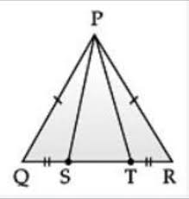

i. Which rule is applied to prove that congruency of ΔPQS and ΔPRT?
ii. Name the type of ΔPST. (1)
iii. If PQ = 6 cm and QR = 7 cm, then find perimeter of ΔPQR.
OR
If ∠QPR = 80°, find ∠PQR.

- Read the following text carefully and answer the questions that follow:
Rohan draws a circle of radius 10 cm with the help of a compass and scale. He also draws two chords, AB and CD in such a way that the perpendicular distance from the center to AB and CD are 6 cm and 8 cm respectively.
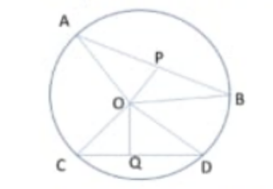

Now, he has some doubts that are given below.
i. Show that the perpendicular drawn from the centre of a circle to a chord bisects the chord. (1)
ii. What is the length of CD? (1)
iii. What is the length of AB? (2)
OR
How many circles can be drawn from given three non-collinear points?

